## **Hands-On Activity: Using R Markdown templates**

**TOTAL POINTS 1**

1.

Question 1



In this activity, you’ll learn how to access and use customized R Markdown templates included in R packages. Templates allow you to use customized documents for a particular purpose. There are lots of R packages that include custom templates for a variety of purposes. For example, templates for academic journal articles, for interactive presentations, or for vignettes summarizing the contents of R packages.

### Example template in RStudio



You’re already familiar with a template in R Markdown from earlier videos. As you may recall, when you create a new R Markdown document from the RStudio menu (File > New File > R Markdown), a default example document (a template) appears in the RStudio source editor:

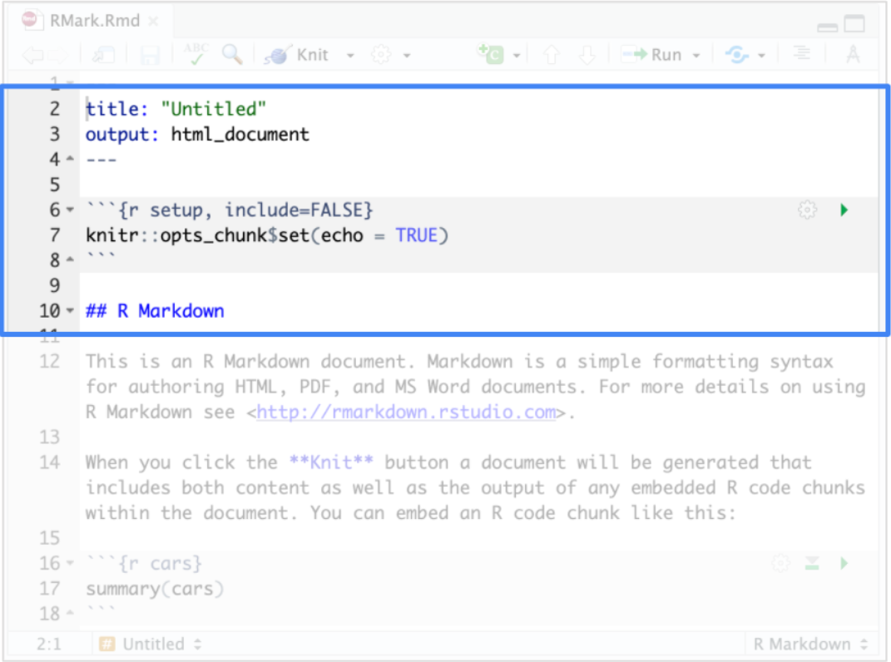

Many customized templates in R packages have a similar structure that includes a YAML header, code chunks, and text headers.

### R packages with templates



Some popular packages with templates for R Markdown include the following:

* The [vitae](https://github.com/mitchelloharawild/vitae) package contains templates for creating and maintaining a résumé or curriculum vitae (CV)
* The [rticles](https://github.com/rstudio/rticles) package provides templates for various journals and publishers
* The [learnr](https://github.com/rstudio/learnr) package makes it easy to turn any R Markdown document into an interactive tutorial
* The [bookdown](https://github.com/rstudio/bookdown) package facilitates writing books and long-form articles
* The [flexdashboard](https://github.com/rstudio/flexdashboard) package lets you publish a group of related data visualizations as a dashboard

### Install a package with a template



Let’s check out a CV template included in the “vitae” package.

First, open up RStudio and run the install.packages() function to install the package:

**install.packages("vitae")**

Then, load the package:

**library(vitae)**

### Access the template in RStudio



In RStudio, you can access available templates in the R Markdown dialog box that appears when you create a new file. So, let’s create a new file in R Markdown: File > New File > R Markdown.

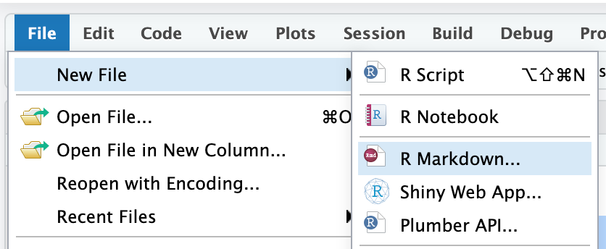

Next, the R Markdown dialog box appears. Click on the From Template heading to access a list of R Markdown templates provided by all installed packages.

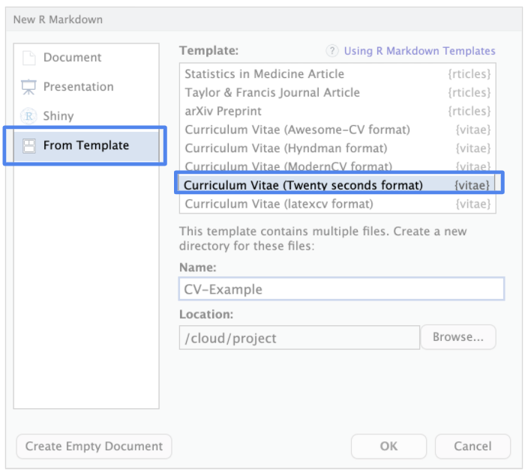

In the viewer, you may notice some template options from the vitae package: Curriculum Vitae (Awesome-CV format), Curriculum Vitae (Hyndman format), Curriculum Vitae (ModernCV format), etc. These are different types of CV templates.

Scroll down and click on Curriculum Vitae (Twenty seconds format). Next, add a name for the new file directory that will contain the files bundled in the template, such as “CV-Example.” Finally, click OK.

### Convert the template to PDF format



The template appears in the source editor pane. It contains a YAML header, code chunks, and text headers, just like the default example document that appears when you create a new R Markdown document. The example CV uses the scientist Marie Curie, the first woman to win a Nobel Prize (and the first person to win two Nobel Prizes). The YAML header contains entries for general information, such as name, address, phone number, etc.

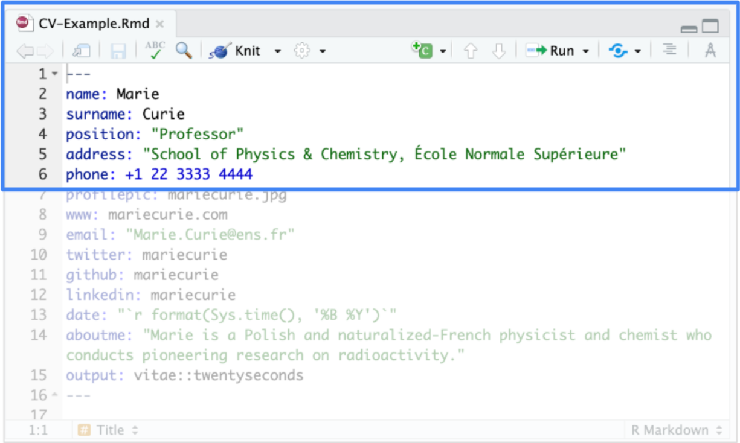

If you scroll down, you discover header text that introduces separate sections for topics like personal information and education:

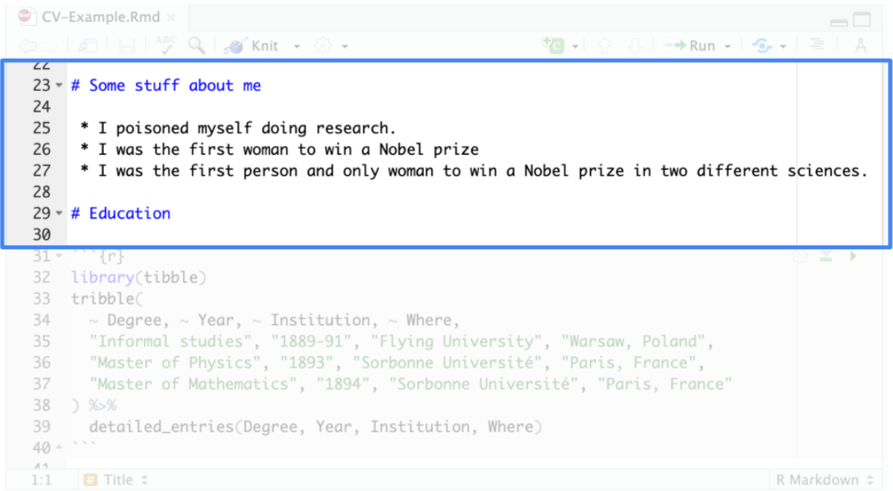

To display the output format of the template, click on Knit to render the file. In this case, you get a PDF that displays the custom template for the CV:

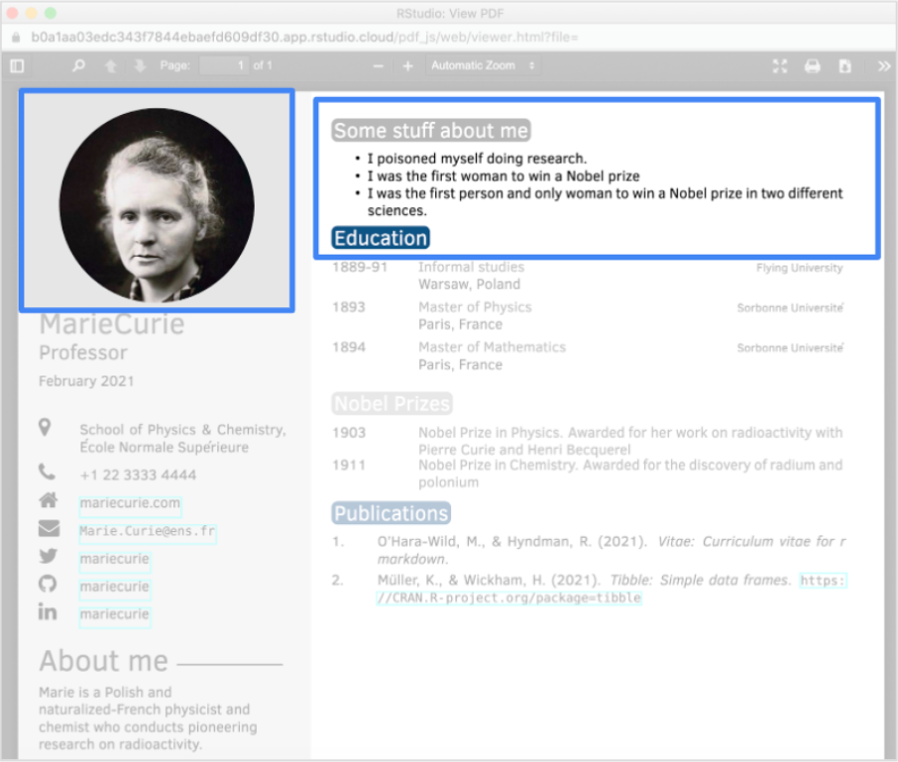

In the PDF, the information in the YAML Header appears on the left side, and the information in the various sections appears on the right side. If you want, you can put your own information into the CV template.

## Did you complete this activity?

1 point

Yes

No